EX. NO.: 12
TITLE
SIMPLE PROGRAMMING USING REPEAT, WHILE
AIM
To learn how to use various MySQL loop statements including WHILE and REPEAT to run a block of code repeatedly based on a condition.

PROCEDURE
WHILE LOOP
- The WHILE loop checks the expression at the beginning of each iteration.
- If the expression evaluates to TRUE, MySQL executes the statements between WHILE and END WHILE.
- The statements are executed repeatedly until the expression evaluates to FALSE.
- The WHILE loop is called a pre-test loop because it checks the expression before the statements execute.
REPEAT LOOP
- First, MySQL executes the statements inside the REPEAT loop.
- Then it evaluates the UNTIL expression.
- If the expression evaluates to FALSE, MySQL executes the statements repeatedly.
- The loop terminates when the expression evaluates to TRUE.
- The REPEAT loop is called a post-test loop because it checks the expression after executing the statements.

PROGRAM-1
Write a function that uses WHILE statement to build a string repeatedly until the value of the variable becomes greater than 5. Then, display the final string using a SELECT statement.
1. Select Database
USE MobileDB;

2. Create Function Using WHILE
DELIMITER //

CREATE FUNCTION WhileExample()
RETURNS VARCHAR(100)
DETERMINISTIC
BEGIN
DECLARE x INT DEFAULT 1;
DECLARE result VARCHAR(100) DEFAULT '';

WHILE x <= 5 DO
SET result = CONCAT(result, x, ' ');
SET x = x + 1;
END WHILE;

RETURN result;
END //

DELIMITER ;

3. Display the Final String
SELECT WhileExample();

PROGRAM-2
Write a function that uses REPEAT statement which would repeat the loop until income is greater than or equal to 4000, at which point the REPEAT loop would be terminated.
1. Create Function Using REPEAT
DELIMITER //

CREATE FUNCTION RepeatExample()
RETURNS INT
DETERMINISTIC
BEGIN
DECLARE income INT DEFAULT 1000;

REPEAT
SET income = income + 1000;
UNTIL income >= 4000
END REPEAT;

RETURN income;
END //

DELIMITER ;

2. Display the Final Income
SELECT RepeatExample();

OUTPUTS
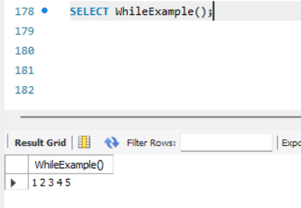

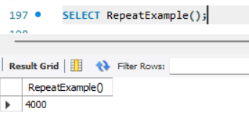

RESULT
Thus the Simple programming exercise using REPEAT and WHILE was executed successfully.

